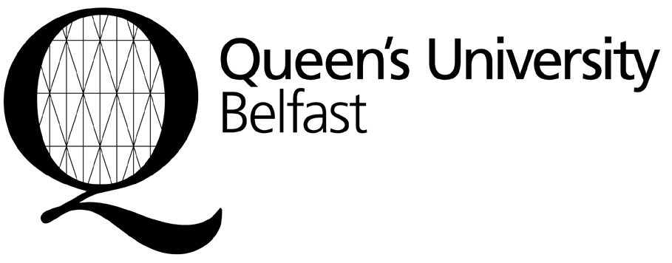
Income and Student Finance Office

Finance Directorate
Student Guidance Centre
Queen’s University Belfast
BELFAST
BT7 1NN
Northern Ireland
United Kingdom
incomeoffice@qub.ac.uk

Early Bird Reward Payment Form (Appendix 2)

This form is to be used by students who have accepted an unconditional offer of a place on a postgraduate taught course, and who wish to pay 90% of the normal tuition fee in advance, thus receiving a 10% fee reduction as follows:

Tuition Fee  ( as stated in Offer Letter) | Value of Early Bird Reward  (10% of fee) | Net Fee to be paid in full to benefit from Early Payment Reward (ie. 90% of fee)
£11,625 | £1,162 | £10,463
£13,000 | £1,300 | £11,700
£14,000 | £1,400 | £12,600
£14,925 | £1,492 | £13,433
£18,000 | £1,800 | £16,200

Payment must be received by the University on or before 5 July 2013.

If you require a receipt, you should complete all sections of this form and send, along with a copy of your offer letter, to the address above. If you do not send this form with full details, we will not be able to supply a receipt. You can enclose the receipt as proof of payment with your application for a student visa. Payment may be made by bank draft drawn on a UK bank, bank transfer, or credit card. If paying by bank draft, please attach this form to the draft.

Family Name:

Given Name:

Nationality:
Date of Birth:

MSc |  |  | MA |  |  | LLM |  |  | MSSc |  |  | Graduate Diploma
Course qualification:
(please tick box)

Course Title:

Student application number:
(Check your offer letter)

Address:

Email:

I wish to pay the following Net Fee (90% of normal tuition fee) to qualify for the 10% Early Payment Reward. Please note that your bank may charge you a fee, which would be in addition to the amount payable to the University.
(please tick one box)
£10,463 |  |  | £11,700 |  |  | £12,600
£13,433 |  |  | £16,200

Signed: …………….………………………………………………………………… Date: ……………………………………..

Once the University has received your payment, a receipt will be sent to the address given.

